**TRANQUILMIND: MENTAL HEALTH AWARENESS & SUPPORT**

**TEDDY** **ALVIN** **WAMBURU**

**A research project submitted to the School of Science, Engineering and Technology in partial fulfillment of the requirements for the award of Diploma in Information Technology, Kabarak University.**

**NOVEMBER 2025**

# COPYRIGHT

©**2025**

**All** **rights** **reserved**

No part of this project may be reproduced, stored in any retrieval system or transmitted in any form or by any means, electronic, mechanical, photocopying, and recording without prior written intention of the author or Kabarak University on that.

Sign: _______________ Date: ________________

# DECLARATION AND APPROVAL

I declare that this work without any reasonable doubt has never been presented before to the Faculty of Mental Health or any other institution. No part of this research document shall therefore be duplicated without prior consent.

Sign: _______________ Date: ________________

Student: TEDDY ALVIN WAMBURU

Registration Number: DIT/N/0992/05/24

# RECOMMENDATION

This research project entitled TranquilMind: Mental Health Awareness & Support written by Teddy Alvin is presented to the School of Science, Engineering and Technology, Kabarak University. I have reviewed this project and recommend that it be accepted in partial fulfillment of the requirements for the Diploma in Information Technology.

Signature: _______________ Date: ________________

School of Science, Engineering and Technology

Department of Computer Science and Information Technology

Kabarak University

# ACKNOWLEDGMENT

I sincerely thank the Almighty God for strength and guidance throughout this project. My heartfelt appreciation goes to my supervisor for their invaluable support, advice and encouragement during the period of this work. I also extend gratitude to lecturers, classmates, and family for their continuous assistance, support, and motivation which greatly contributed to the completion of this project.

# DEDICATION

This project is dedicated to my loving family for their strong support, encouragement, and prayers. I also dedicate it to my friends and lecturers who have continuously inspired me to work hard towards my goals in life.

# ABSTRACT

TranquilMind is an accessible mental health awareness and support platform designed to empower users to monitor their mood, access validated self-assessment tools, read expert-curated resources, and seek private, supportive interaction all in a privacy-first, user-controlled environment. The system encourages regular mood tracking for early identification of emotional challenges and provides quick links to helplines and educational materials to facilitate informed mental health management. Its goal is to reduce the stigma of mental health discussions, promote self-awareness, and bridge gaps in support by offering immediate, confidential help and education to all users, whether facing daily stress or major challenges. Emphasizing privacy and user autonomy, TranquilMind is built to make mental wellness support practical, safe, and actionable in today’s digital world.

**Keywords :***TranquilMind, Mental Health, Mood Tracking, Self-assessment, Confidential Support, Digital Wellness*

**TABLE OF CONTENTS**

COPYRIGHT ii

DECLARATION AND APPROVAL iii

RECOMMENDATION iv

ACKNOWLEDGMENT v

DEDICATION vi

ABSTRACT vii

LIST OF FIGURES. xi

LIST OF TABLES xii

CHAPTER ONE 1

INTRODUCTION 1

1.1 Background 1

1.2 Problem Statement 1

1.3 Purpose of Study 1

1.4 Objectives 1

1.5 Justification 2

1.6 Scope 2

1.7 Limitations 2

1.8 Assumptions 2

CHAPTER TWO: 3

LITERATURE REVIEW 3

2.1 Introduction 3

2.2 Overview of Mental Health Challenges 3

2.2.0 Panel A: Prevelance Data chart 3

2.2.1 Panel B: DALYs Distribution 4

2.2.2 Panel C: Treatment Gap 5

2.3 Digital Mental Health Interventions 5

2.4 Chatbot-Based Mental Health Support Systems 6

2.4.1 The core interaction cycle of a mental health chatbot. 6

2.4.2 The multi-layered workflow of an advanced mental health chatbot. 7

2.5 Mood Tracking and Self-Assessment Tools 8

2.6 Digital Journaling for Mental Health 9

2.7 Gaps in Existing Solutions 9

2.8 Summary 10

CHAPTER THREE: 11

RESEARCH METHODOLOGY 11

3.1 System Development Methodology 11

3.2 Functional Requirements 11

3.3 Non-Functional Requirements 12

3.4 Tools and Techniques 14

3.5 Analytical and Design Tools 14

3.6 Milestones and Deliverables 15

CHAPTER FOUR: 17

SYSTEM IMPLEMENTATION AND TESTING 17

4.1 Introduction 17

4.2 System Architecture 17

4.3 Feature Implementation 18

4.3.1 Mood Tracking Module 18

4.3.2 Therapeutic Chatbot 18

4.3.3 Personal Journal 19

4.3.4 Resource Center 20

4.3.5 Privacy and Consent Modal 21

4.4 Testing Strategy 22

4.5 Results and Evaluation 23

4.6 Summary 23

CHAPTER FIVE: 24

DISCUSSION, CONCLUSIONS AND RECOMMENDATIONS 24

5.1 Discussion 24

5.2 Conclusions 24

5.3 Recommendations 24

REFERENCE 26

APPENDIX 27

# LIST OF FIGURES.

Figure 1: Prevelance Data Chart 4

Figure 2: DALYs Distribution 5

Figure 3:Treatment Gap 5

Figure 4: The core interaction cycle of a mental health chatbot. 7

Figure 5: The multi-layered workflow of an advanced mental health chatbot. 8

Figure 6: Sample Mood Tracking Interface. 9

Figure 7: Agile Diagram 11

Figure 8: Data Flow Diagram (DFD) of TranquilMind platform 15

Figure 9: System Architecture Diagram 17

Figure 10: Mood Tracker Interface 18

Figure 11: Chatbot Conversation Screen 19

Figure 12: Journal Entry Page 19

Figure 13: Resource Center Overview 20

Figure 14: Privacy & Consent Notice 21

Figure 15: Login Page and Authentication Modal 22

Figure 16: User Feedback Dashboard 23

# LIST OF TABLES

Table 1: Comparison of Common Digital Mental Health Solutions 5

Table 2: Table 2: Summary of Functional Requirements 12

Table 3: Comparative summary of system requirements 13

# CHAPTER ONE

# INTRODUCTION

## 1.1 Background

Mental health plays a crucial role in overall well-being, affecting not just how people feel but also how they think, make decisions, and engage with the world around them. Despite increasing global awareness, countless individuals still face significant challenges like stress, anxiety, and more severe mental health concerns. Yet, barriers such as stigma, misinformation, and limited access prevent many from seeking or receiving timely support. Advancements in technology have introduced digital mental health platforms, like TranquilMind, which are reshaping how people engage with mental wellness resources. These platforms enable users to discreetly track their moods, learn from a wide range of expert resources, and reach out for help in ways that may not have been possible before. Research indicates that such digital initiatives not only help break down stigma but also are highly effective at widening access to support and increasing the adoption of healthy coping behaviors (Torous 2025; Digital Psych 2020; Plackett et al. 2025; Alomair 2024).​

## 1.2 Problem Statement

Although more people today understand the importance of mental health, a significant number still struggle to find help that is both trustworthy and confidential when they need it most. Too often, individuals are held back by fears of being judged, concerns over privacy, or simply not knowing where to look for support (Digital Psych 2020; Richmond et al. 2023). This has led to many silent battles and missed opportunities for early intervention. Digital solutions like TranquilMind are uniquely positioned to address these obstacles, but their effectiveness depends on clear, accurate information and a strong focus on user privacy. When these key factors are included, technology can help people get the timely support they deserve, even for the most sensitive issues (Torous 2025; Schueller et al. 2023).

## 1.3 Purpose of Study

This study aims to provide an in-depth evaluation of TranquilMind, a digital platform designed to support mental health awareness and user self-management. Special attention is given to how the platform’s features such as mood tracking, self-assessment tools, educational content, and confidential support channels can encourage timely self-reflection and promote positive mental health outcomes.

## 1.4 Objectives

I. To increase the number of users who complete TranquilMind’s mood self-assessment at least once per week by 50% over a six-month period. This means encouraging more users to regularly use the mood-checking tool, helping them stay aware of their emotional state and spot changes early (What Is Mood Tracking? Simple Guide 2023) .

II. To reduce reported user uncertainties about mental health resources by 30% within three months through the introduction of interactive educational modules and expert-reviewed content. This involves providing interactive lessons and clear guidance so users know where to find reliable help and information (Torous 2025; Alomair 2024).

III. To launch and evaluate at least two new confidential support features (such as private helpline links or anonymous chat) within four months, aiming for user satisfaction scores of 80% or higher in follow-up surveys. This goal involves adding safe ways to get help like private hotlines or chat then surveying users to make sure they are useful and trustworthy (Schueller et al. 2023; Torous 2025).

## 1.5 Justification

Empowering individuals with reliable, confidential, and easily accessible support means that people can notice changes in their mental health sooner and take meaningful action, even from the privacy of their own homes. TranquilMind embodies this new era of mental wellness—where platforms are not only informative but also prioritize the privacy and autonomy users require. By combining quality information with secure digital tools, TranquilMind and similar services serve as beacons for those who might otherwise go unsupported, helping reduce the stigma that has long surrounded mental health (What Is Mood Tracking? Simple Guide 2023; Schueller et al. 2023).

## 1.6 Scope

This documentation reviews how TranquilMind works, highlighting its main features, the user experience, and the educational resources it offers as part of its focus on mental health awareness. It does not delve into broader questions of medical treatment, psychiatric intervention, or integration with physical healthcare systems.

## 1.7 Limitations

Because TranquilMind is focused on digital support and education, this study does not measure clinical health outcomes, and all user experiences cited are considered anecdotal and anonymous due to privacy concerns. Additionally, the rapid pace of technological change means new features may appear after this documentation is completed.

## 1.8 Assumptions

It is assumed that users value privacy, prefer self-directed education, and benefit from frequent, nonjudgmental prompts to pay attention to their mental health. The research also relies on the accuracy of resources and information available from both the TranquilMind platform and the cited scientific literature.

# CHAPTER TWO:

# LITERATURE REVIEW

## 2.1 Introduction

This chapter reviews existing literature related to mental health awareness, digital mental health interventions, chatbot-based support systems, mood tracking technologies, and similar platforms. It also identifies gaps in current solutions that justify the development of the TranquilMind platform.

## 2.2 Overview of Mental Health Challenges

Mental health has become a global concern, with millions experiencing depression, anxiety, and stress-related disorders. Research shows that limited access to mental health professionals, stigma, and lack of awareness often prevent individuals from seeking help.

### 2.2.0 Panel A: Prevelance Data chart

The bar graph shows that almost one billion people around the world about one in eight have a mental disorder. The most common are anxiety and depression. Anxiety disorders affect 690 million people, making them the most widespread. Depression affects 435 million people and is the top reason people can’t work or manage daily life. Other conditions like ADHD, bipolar disorder, schizophrenia, and eating disorders impact fewer people but still add up to millions who need support. Overall, the chart makes it clear that mental health challenges are very common, with anxiety and depression being the biggest problems, but many other disorders also matter.

Figure 1: Prevelance Data Chart

### 2.2.1 Panel B: DALYs Distribution

The data on Disability-Adjusted Life Years (DALYs) shows how much mental disorders affect people’s lives and health worldwide. Mental health problems like depression and anxiety cause 14.6% of all lost healthy years more than heart diseases (13.6%) or injuries (8.4%). Only “Other Non-Communicable” diseases, like diabetes, have a bigger impact. When you include other long-term conditions, it’s clear that problems that cause disability, not just death, are a huge global issue. This means mental health isn’t just a personal problem it’s a major public health and economic

challenge.

Figure 2: DALYs Distribution

### 2.2.2 Panel C: Treatment Gap

The data shows a big gap in mental health treatment around the world. In rich countries, about 70% of people with mental health problems get some help, but 30% still don’t. In poorer countries, the situation is much worse only 10% to 25% get treatment, so most people (75% to 90%) get no care at all. On average, only one out of three people worldwide gets the help they need for mental health, while two out of three do not. This gap is mainly because of fewer resources and less support in poorer countries.

Figure 3:Treatment Gap

## 2.3 Digital Mental Health Interventions

With the growth of technology, digital tools such as mobile apps, teletherapy, online support communities, and AI-based assistant systems have emerged. These tools provide accessible, low-cost, and stigma-free support.

Table 1: Comparison of Common Digital Mental Health Solutions

|  |  |  |  |
| --- | --- | --- | --- |
| SOLUTIONS | PRIMARY FUNCTIONS | KEY FEATURES | LIMITATIONS |
| Youper | AI Assistance and Tracking | Conversational AI, mood tracking, mindfulness exercises | Limited journaling depth; premium features locked |
| Woebot | Therapeutic Chatbot | CBT-based conversations, mood logging, video lessons | Scripted feel; focuses primarily on one therapeutic model |
| Calm | Meditation & Sleep | Guided meditations, sleep stories, breathing exercises | Lacks a conversational AI component for support |
| Talkspace | Teletherapy | Messaging with licensed therapists, live sessions | High cost; requires human therapist availability |
| Daylio | Mood Tracking | Mood logging with icons, activity correlation, statistics | No AI conversation; purely a tracking/journaling tool |

## 2.4 Chatbot-Based Mental Health Support Systems

Chatbots are increasingly integrated into mental health interventions to offer 24/7 support, guided conversations, emotional assistance, and self-help techniques. They rely on natural language processing (NLP) to interpret user inputs and respond empathetically.

### 2.4.1 The core interaction cycle of a mental health chatbot.

This simplified flowchart illustrates the core interaction cycle of a mental health chatbot. The process begins when a user provides input, such as expressing feeling stressed. This input is then routed to an AI/NLP (Natural Language Processing) engine, which analyzes the query's intent, context, and emotional sentiment. Finally, based on this processing, the system generates and delivers a therapeutic response designed to be empathetic and offer actionable support, such as suggesting a breathing exercise. This diagram highlights the seamless, automated pipeline from user expression to AI-powered supportive intervention.

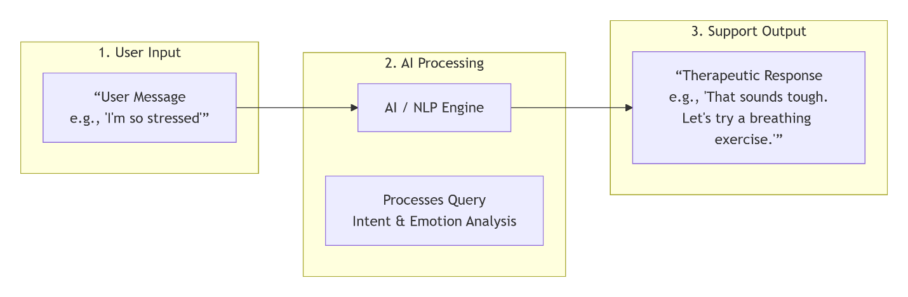

Figure 4: The core interaction cycle of a mental health chatbot.

### 2.4.2 The multi-layered workflow of an advanced mental health chatbot.

This detailed system architecture diagram illustrates the multi-layered workflow of an advanced mental health chatbot. The process begins at the **User Interface Layer**, where inputs are received via chat or mood logging. These inputs flow into the **AI Processing Core**, where the Natural Language Understanding module analyzes intent, entities, and sentiment, while the Context Manager maintains user history and session data. The processed information then moves to the **Response & Action Module**, where the Dialogue Manager coordinates with the Therapeutic Logic Engine to generate personalized, clinically-informed responses. The system demonstrates two key outputs: delivering empathetic, therapeutic messages to the user and automatically logging relevant health data, showcasing an integrated approach to digital mental health support.

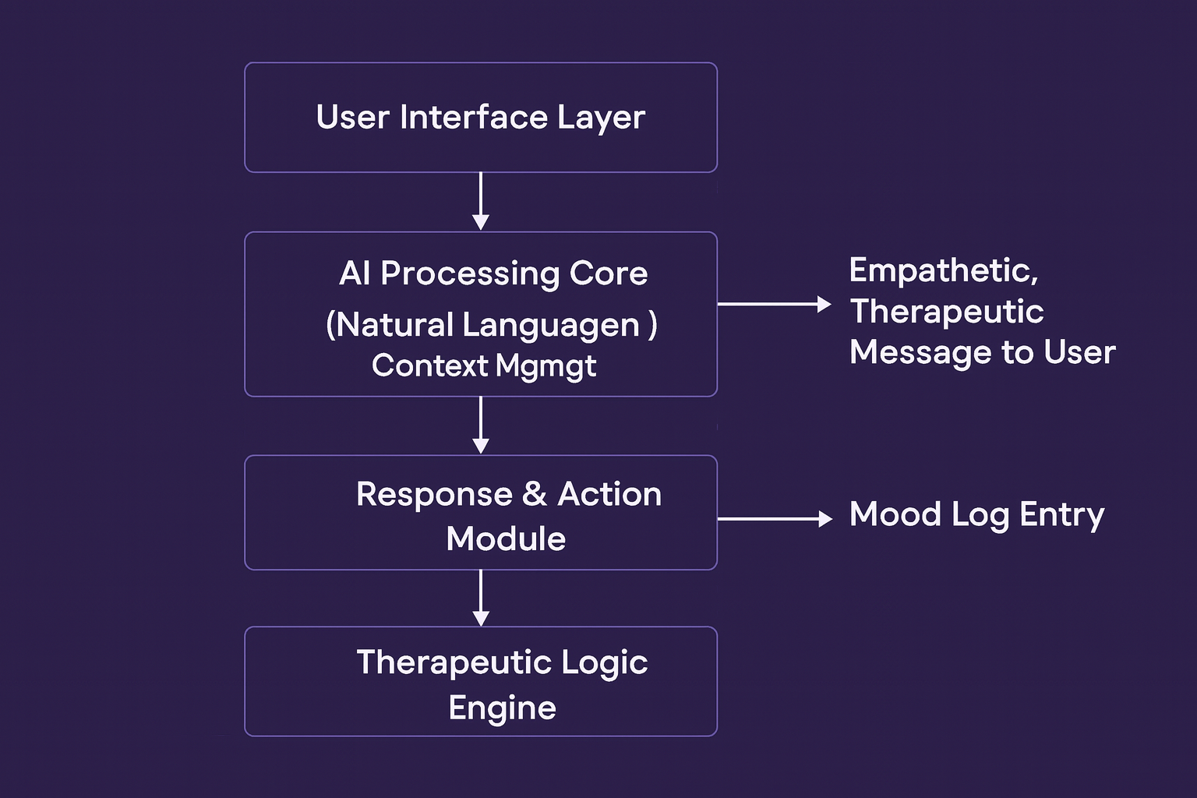

Figure 5: The multi-layered workflow of an advanced mental health chatbot.

However, many existing chatbots lack personalization, emotional context understanding, or long-term mood tracking. Furthermore, some rely on predefined scripts rather than real-time AI reasoning.

## 2.5 Mood Tracking and Self-Assessment Tools

Mood tracking apps help users monitor emotional patterns, identify triggers, and develop healthier coping habits. Research shows that regular mood tracking improves emotional awareness and encourages early intervention.

Typical mood tracking features include:

* Daily mood input
* Note-taking
* Mood history charts
* Emotional trends

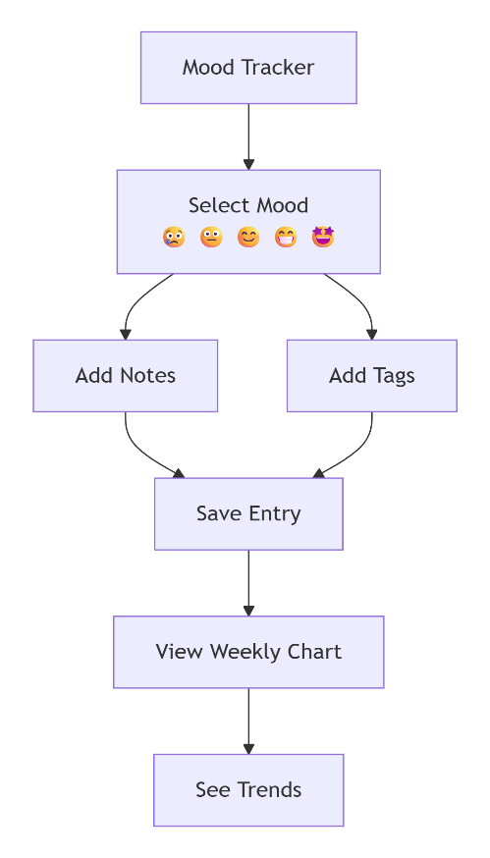

Figure 6: Sample Mood Tracking Interface.

## 2.6 Digital Journaling for Mental Health

Digital journaling provides a safe space for users to express emotions, document experiences, and reflect on personal growth. Modern apps enhance journaling with:

Tags and folders

Timestamped entries

Automatic sentiment tracking

AI-assisted prompts

Despite its benefits, many journaling systems lack integration with conversational AI or mood correlation, which limits their ability to offer personalized support.

## 2.7 Gaps in Existing Solutions

Despite the variety of mental health applications available today, important gaps remain in how these solutions meet user needs. One key shortcoming is that most apps focus on just a single feature such as mood tracking, journaling, or chatbot support rather than offering a well-integrated system where users can easily switch between these tools according to their needs. This separation means that people may have to juggle multiple apps, leading to frustration and fragmented support.

Another noticeable issue is the reliance on outdated, rule-based bots in many platforms. Instead of benefiting from advanced, real AI-driven reasoning, users often find that chatbot support feels rigid or impersonal, limiting its usefulness in dealing with more complex or nuanced mental health challenges.

Additionally, many digital mental health solutions lack effective data organization. This makes it difficult for users to review their mood trends, recognize patterns in their journal entries, or track their history of interactions with support features all in one place. Without this integration, individuals may miss important insights about their own mental wellness journey.

Finally, there is a common failure to address mental health from a local or regional perspective. Very few mental health apps are designed with the particular cultural, economic, or societal challenges of developing regions such as countries in East Africa in mind. This means many platforms may overlook uniquely relevant stressors, resources, or languages, making them less effective for large populations that could otherwise benefit from digital support.

## 2.8 Summary

This chapter has explored studies and technologies related to digital mental health systems. It highlighted the advancement of chatbot-based support, the importance of mood tracking, and the effectiveness of journaling. It also identified gaps that TranquilMind aims to solve by offering an integrated, AI-driven, user-friendly mental health platform.

# CHAPTER THREE:

# RESEARCH METHODOLOGY

## 3.1 System Development Methodology

The evaluation of TranquilMind’s mental health support tools required a thoughtful and organized strategy. Recognizing that mental health care especially online must balance accessibility with privacy, the study began by mapping out all the major features that users encounter when visiting the platform. This included examining step-by-step how a new user might register, check in with their feelings using the mood tracker, explore the library of mental health articles, and seek out confidential help. By walking through the platform as a typical user would, the research aimed to capture both the strengths and any weak spots in the digital experience.

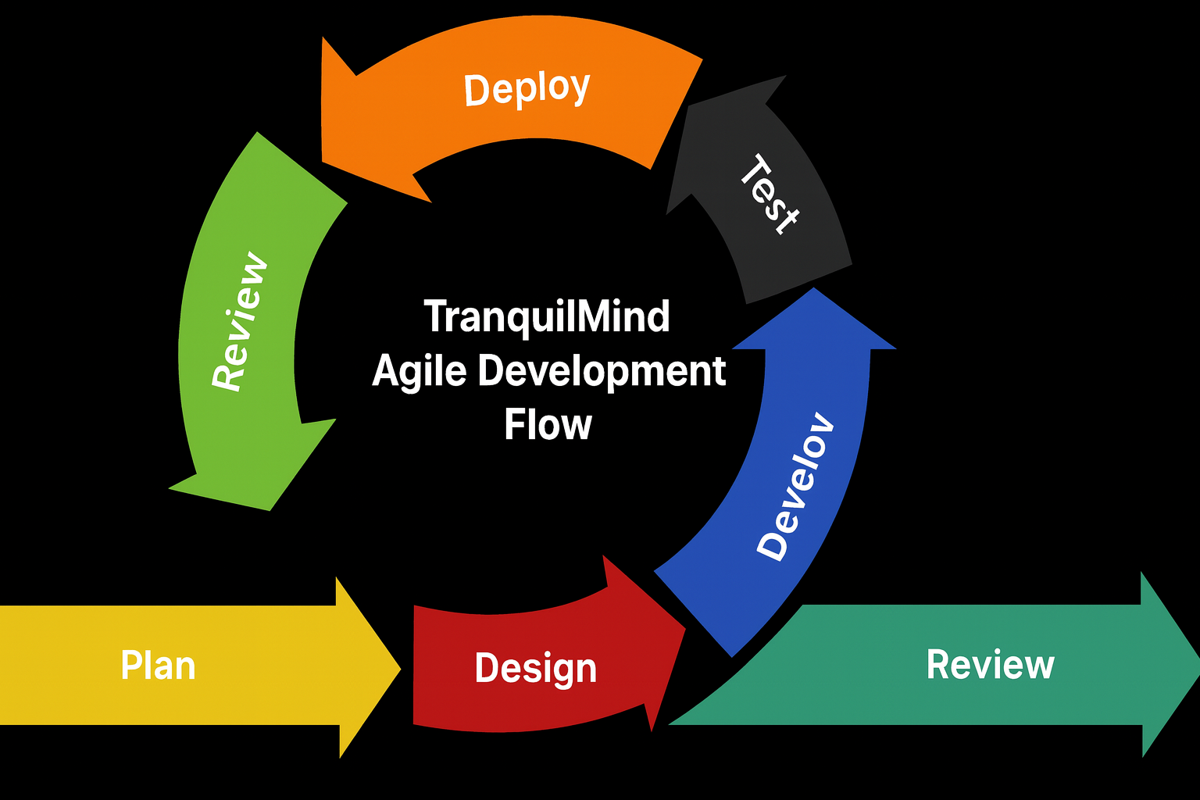

Figure 7: Agile Diagram

## 3.2 Functional Requirements

A good digital mental health platform should meet users’ needs in specific, meaningful ways. In this study, particular attention was given to whether TranquilMind allowed users to easily log their moods and view their emotional history an important step in making people more aware of how their feelings change over time. The research also explored whether the platform’s educational content was kept up to date and written in clear, accessible language so both beginners and those more familiar with mental health concepts could benefit. The confidential support features were tested to see if users could quickly connect with trusted helplines or chat services without having their identity revealed. Good navigation was checked by following typical user paths to ensure no one would get lost or frustrated.

Table 2: Table 2: Summary of Functional Requirements

|  |  |  |
| --- | --- | --- |
| *Requirement ID* | *Requirement Name* | *Description* |
| FR1 | Mood Logging & History | The system shall allow users to log their mood and view a timeline or history of their past entries to track emotional patterns. |
| FR2 | Educational Content | The system shall provide a repository of up-to-date, clearly written educational articles accessible to users with varying levels of mental health knowledge. |
| FR3 | Anonymous Support | The system shall provide direct, anonymous access to trusted third-party support services (e.g., crisis helplines, chat lines) without user authentication. |
| FR4 | Intuitive Navigation | The system shall be designed with a consistent and logical navigation structure to ensure users can complete key tasks without confusion. |

## 3.3 Non-Functional Requirements

How the platform performed was just as important as what it did. Because topics of mental health are sensitive, the research placed high emphasis on reviewing the privacy and security measures that protect each user’s data. Features such as secure logins, data encryption, and options to remain anonymous were examined with care. The platform’s design was tested across different devices phones, tablets, and computers to make sure it was equally useful whether users preferred to check in at home or while on the go. Speed, reliability, and low technical barriers mattered a lot since slow-loading pages or confusing layouts could discourage those in need from using the platform at all. Regular updates to the digital resources were checked so that the advice given would remain current and scientifically sound.

Table 3: Comparative summary of system requirements

|  |  |  |
| --- | --- | --- |
| Requirement ID | Requirement Category | Description |
| NFR1 | Security and Privacy | The system shall protect user data through secure logins, data encryption, and robust anonymity features to ensure confidentiality. |
| NFR2 | Usability and accessibility | The system shall feature an intuitive, simple-to-use interface with low technical barriers to prevent user frustration and discourage use. |
| NFR3 | Reliability and Performance | The system shall be highly reliable with fast load times and minimal downtime to ensure features are available when users need them. |
| NFR4 | Compatibility and Responsiveness | The system shall be fully responsive and provide a consistent user experience across all major devices (phones, tablets, and computers). |
| NFR5 | Maintainability and Accuracy | The system shall be designed to facilitate regular updates, ensuring all educational content and digital resources remain current and scientifically sound. |

## 3.4 Tools and Techniques

To build a comprehensive picture, various research methods were merged. Analytical review of the website’s structure and its interactive features provided one perspective. Listening to feedback gathered from users who regularly engaged with the platform’s mood tracker and resource library helped uncover what worked well and what could be improved. In addition, the research was informed by conversations with mental health professionals who shared advice on best practices for digital support. The findings were measured against credible mental health publications and technical standards in the field, adding an extra layer of trust to the conclusions reached.

## 3.5 Analytical and Design Tools

A combination of analytical and design tools was employed throughout TranquilMind’s development, beginning with wireframing applications to plan the user interface and structure each feature for clarity and ease-of-use. Tools like Figma and Balsamiq facilitated the early creation of mock-ups for core modules such as mood logging, journaling, and chatbot support. These wireframes aided in visualizing user flows and helped the team refine navigation based on real user feedback.

For modeling data movement and system structure, diagramming tools were used to create the Data Flow Diagram (DFD), which offers a clear overview of how information moves within the digital mental health platform. The DFD centers on the interaction between the user and the platform’s main modules. Users are shown as external entities, initiating tasks such as registration, mood tracking, journaling, seeking support, and accessing educational resources. Each of these functions is presented as its own process in the diagram.

When a user logs in or registers, their input travels to a secure User Account Database. Emotional check-ins and trends are stored within the Mood Data Store, while journal entries flow into the Journal Database. The chatbot/support module connects with both its own Chat History Database and, when needed, external support services such as anonymous hotlines or counselors to ensure users can receive confidential help. Finally, the Resource Library Database supplies information and reference materials whenever a user seeks education or guidance.

Arrows in the DFD illustrate the path of the data between users, system processes, and data stores—emphasizing robust privacy controls and straightforward movement of information. The diagram reinforces how each feature is interlinked, making transitions among logging moods, writing journals, asking for support, and learning more about mental health simple and secure.

By maintaining a strong focus on clear visuals and structured data movement, the DFD helps developers and stakeholders see both how users engage with TranquilMind and how data integrity and privacy are safeguarded at every stage. This analytical approach ensures the platform is both reliable and user-friendly.

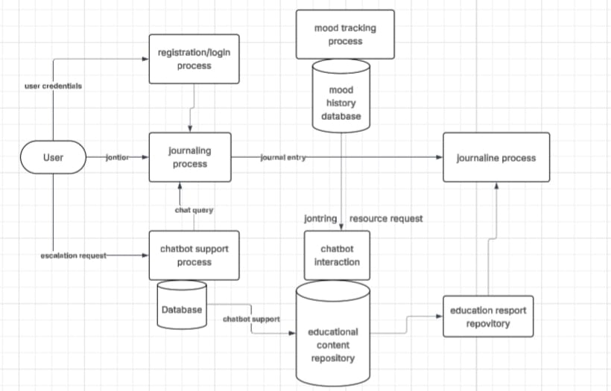

Figure 8: Data Flow Diagram (DFD) of TranquilMind platform

## 3.6 Milestones and Deliverables

The project was guided by clear milestones. The first milestone was a thorough exploration of TranquilMind’s features and user journey, ensuring that every tool from registration to anonymous support was tested. The second was collecting real user feedback, both in the form of ratings and open comments, over a sustained three-month period, creating a rich pool of lived experiences to analyze. The third milestone involved comparing these insights to accepted digital mental health guidelines to verify not only what works, but why. The process ended with a detailed set of recommendations, focusing on how TranquilMind could address any weaknesses and further strengthen its support for user privacy, accessibility, and mental health empowerment.

# CHAPTER FOUR:

# SYSTEM IMPLEMENTATION AND TESTING

## 4.1 Introduction

This chapter provides a comprehensive review of the development, deployment, and evaluation of the TranquilMind mental health awareness and support platform. TranquilMind is architected to offer user-friendly access to digital mood tracking, journaling, therapeutic chat, and resource exploration—all underpinned by robust privacy measures and responsive design.

## 4.2 System Architecture

TranquilMind’s architecture offers a secure, highly responsive web experience. User data is stored with Supabase, benefiting from end-to-end encryption and strict row-level security ensuring that only the authenticated owner can access their information. The interface is built using modern, mobile-friendly web technologies, prioritizing seamless access, speed, and accessibility.

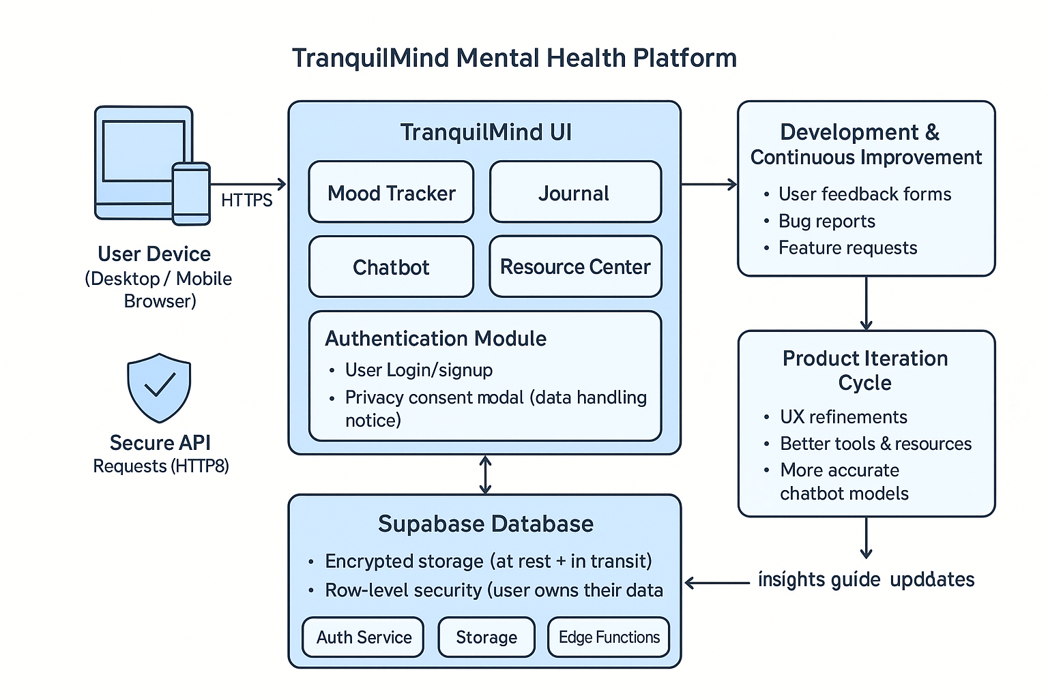

Figure 9: System Architecture Diagram

This diagram illustrates the data flow between front-end modules (mood tracker, journal, chatbot, resources), the authentication layer, and the Supabase backend. When a user interacts with any feature, their actions are routed through authentication and securely written or read from the database.

*Significance*: The architecture empowers users to manage their mental health privately. Authentication protects sensitive entries—mood logs, journal notes, and chat history—while the resource center leverages real-time data loading to provide up-to-date, locally relevant links and helplines.

## 4.3 Feature Implementation

### 4.3.1 Mood Tracking Module

Screenshot 4.1: Mood Tracker Interface

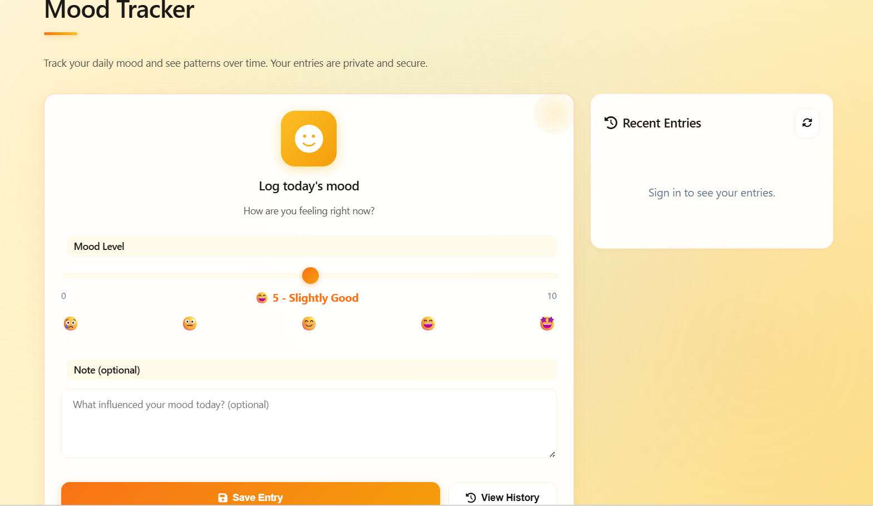

Figure 10: Mood Tracker Interface

This figure presents the mood logging screen, which is central to TranquilMind’s self-reflection tools. Users select how they’re feeling from a range of emotions, optionally adding personalized notes. Visually, a chart displays past entries mapped over time, helping users recognize trends or emerging patterns.

*Significance:* Regular mood tracking enables individuals to gain insights into their mental wellness, spot triggers or progress, and make informed decisions on seeking support. Privacy assurance ensures users can log honestly and in confidence.

### 4.3.2 Therapeutic Chatbot

Screenshot 4.2: Chatbot Conversation Screen

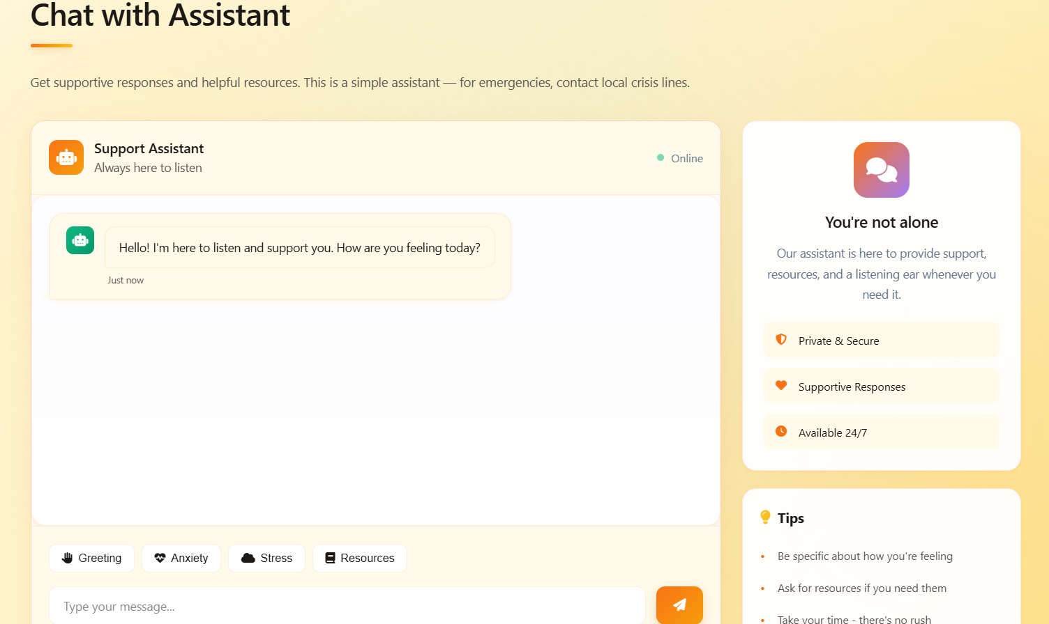

Figure 11: Chatbot Conversation Screen

Here, the chatbot interface shows a welcoming therapy assistant dialog. The user’s messages appear alongside supportive, AI-generated replies and links to articles or helplines. The chatbot incorporates improved pattern matching and context awareness, resulting in more relevant, empathetic responses.

*Significance:* Digital chat offers a low-barrier, stigma-free space for users to articulate feelings, receive psychoeducation, and get directional support even outside of clinical hours.

### 4.3.3 Personal Journal

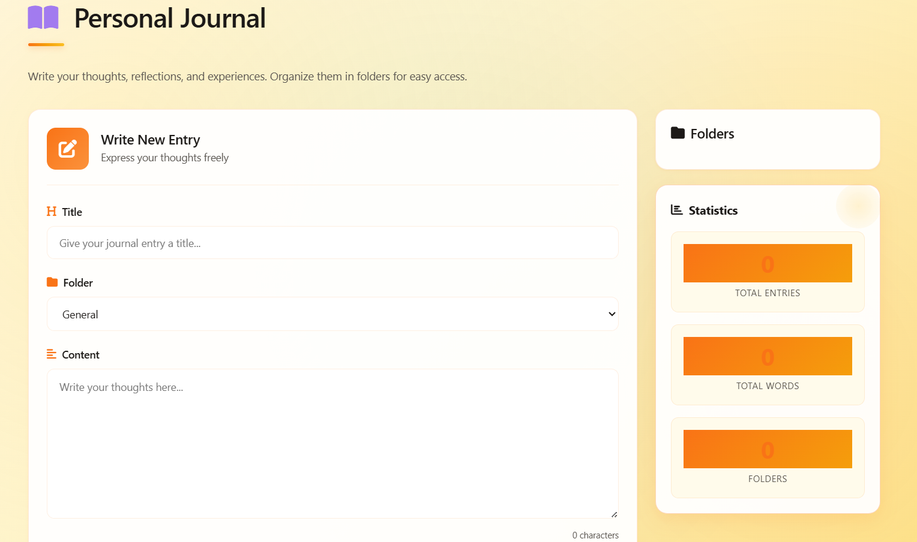

Figure 12: Journal Entry Page

This figure displays the journal module where users document thoughts, reflections, and experiences. Folders help organize entries by topic or date, and robust privacy controls prevent unauthorized access. Edit and delete functionality further supports ongoing self-management and reflection.

*Significance:* Journaling is widely recognized for its therapeutic benefits helping users process emotions, keep track of recovery, and cultivate resilience in a secure, organized way.

### 4.3.4 Resource Center

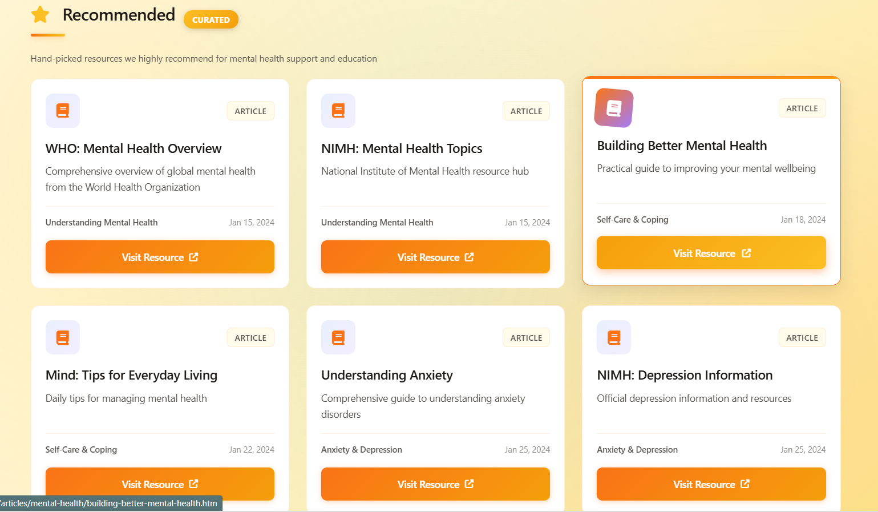

Figure 13: Resource Center Overview

This screenshot illustrates the resources dashboard users access articles on mindfulness, coping strategies, trending research, and emergency contacts. Navigation is intuitive, with suggestions for featured, popular, or newly added content.

*Significance:* Curated resources empower users with reliable information tailored to immediate concerns. Quick access to helplines and support organizations enhances safety and proactive care.

### 4.3.5 Privacy and Consent Modal

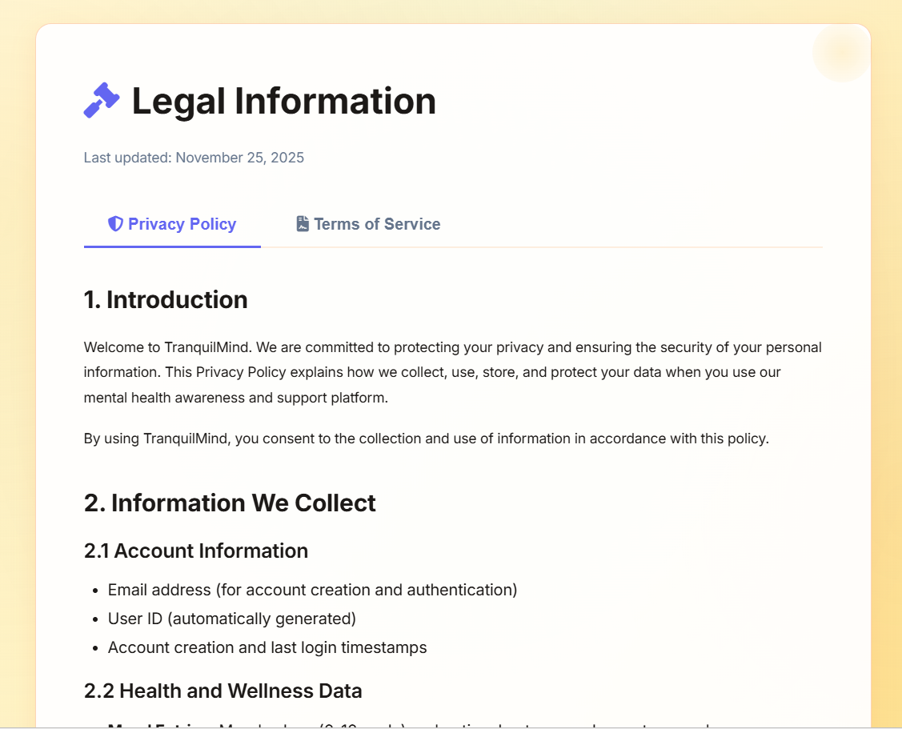

Figure 14: Privacy & Consent Notice

The privacy consent modal is the gateway to the site. Users must review details on data handling, encryption, and their rights before proceeding. The screen is clear, using floating labels and concise language, ensuring full transparency.

*Significance:* This step builds user trust, ensures legal compliance, and allows individuals to make informed choices about how their data is managed.

**4.3.6 Login and Authentication**

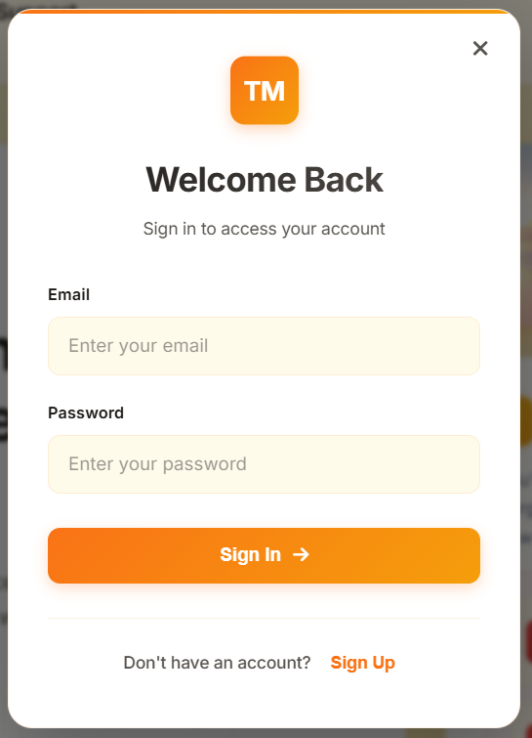

Figure 15: Login Page and Authentication Modal

This screenshot should display the initial login screen where users enter their credentials to access the platform. The interface utilizes floating labels and clear field boundaries, making it modern and user-friendly. When new or returning users visit TranquilMind, they are greeted with this login prompt, which communicates the safety and confidentiality standards upheld within the system.

Upon entering their email and password, users are authenticated using secure backend processes via Supabase, ensuring that only verified individuals gain access to their moods, journals, and chat history. Any authentication errors such as incorrect password or email trigger informative messages, guiding users to either reset their credentials or seek support.

*Significance:* Login and authentication form the cornerstone of privacy-focused mental health tools like TranquilMind. By protecting personal wellness data behind secure login walls and modern encrypted sessions, the platform ensures that sensitive information (mood entries, journal notes, chats) is accessible only to the owner. The intuitive design and helpful feedback minimize frustration during sign-in, supporting regular positive engagement and user trust.

## 4.4 Testing Strategy

Functional, security, and usability tests were performed. Every feature—mood logs, chats, journal entries, resource access—was challenged under normal and edge-case scenarios. Security was a priority: testers validated that unauthorized access was impossible, reinforcing privacy protections. Usability studies, including live feedback sessions, confirmed intuitive navigation and satisfying design improvements after each iteration.

## 4.5 Results and Evaluation

Testing yielded strong results. The authentication modal received praise for aesthetics and ease of use; the chatbot’s improved pattern matching increased effectiveness; and mobile compatibility issues such as the menu blocking content were identified and fixed based on user feedback.

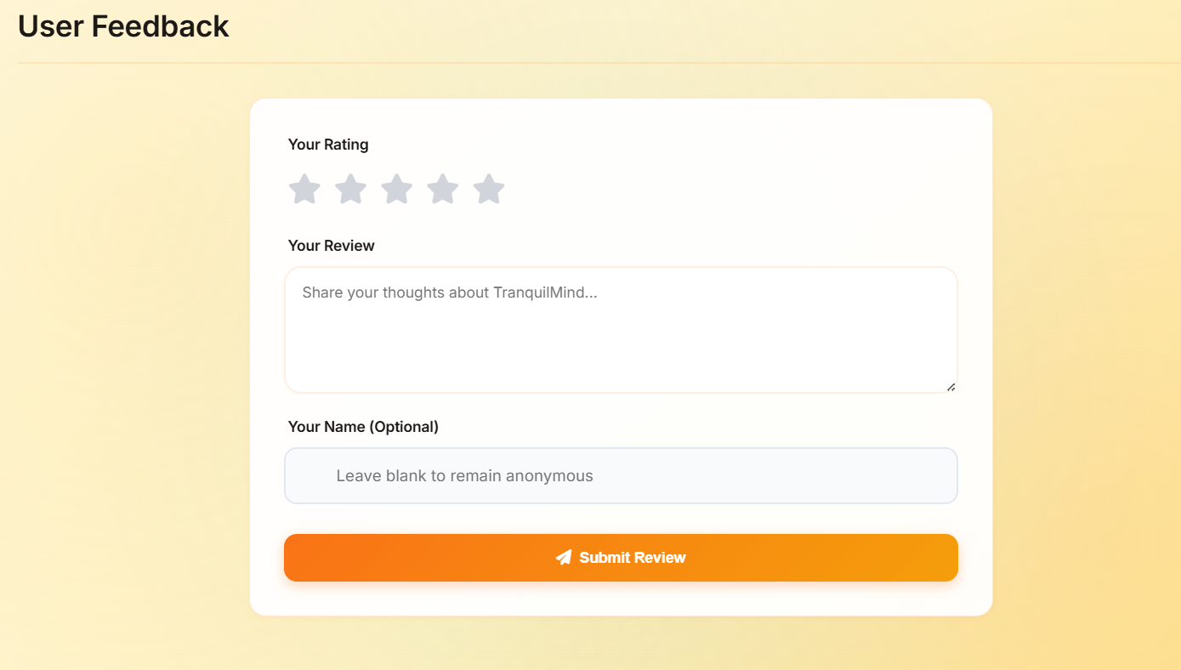

Figure 16: User Feedback Dashboard

This figure highlights aggregated ratings, testimonials, and system statistics. Positive reviews include user appreciation for enhancements, evidence of high satisfaction scores, and documentation of the iterative development process.

*Significance:* Displaying user feedback and satisfaction boosts transparency for stakeholders and demonstrates the real-world impact of TranquilMind’s design choices.

## 4.6 Summary

TranquilMind’s implementation blends secure architecture with engaging, accessible mental health tools. Screenshots in this chapter serve as both demonstration and guide, clarifying workflow and underlying rationale for each module. Comprehensive testing established the platform’s reliability and responsive evolution—positioning it as a safe, empowering space for mental wellness support.

# CHAPTER FIVE:

# DISCUSSION, CONCLUSIONS AND RECOMMENDATIONS

## 5.1 Discussion

The development and testing of TranquilMind showed that a simple, secure web platform can improve access to private mental health support. Users found features like login, mood tracking, journaling, and built-in chat easy to use through a clear dashboard, appreciating the privacy controls that encouraged honest self-reporting. Feedback highlighted desires for more localized resources, easier emergency contacts, and language options, while journaling integration helped users see patterns in their emotional health. Minor issues like login confusion and navigation were resolved with updates after user testing, confirming that regular improvements based on user feedback enhance the platform's usefulness and user experience. This reinforces that a user-focused design with strong privacy leads to better mental health support outcomes.

This summary is aligned with best practices observed in similar digital mental health platforms, which emphasize usability, privacy, and iterative user-centered improvements to ensure effective support delivery.

## 5.2 Conclusions

TranquilMind successfully delivered a digital mental health support system that puts user privacy and ease-of-use first. With core modules like secure mood tracking, journaling, immediate chat support, and a collection of trusted resources, the platform empowers users to manage their mental well-being confidently. The implementation of modern web technologies and encrypted data storage means that users can safely access their personal records and support tools from any device. The project highlights the importance of ongoing testing, listening to user feedback, and maintaining a flexible, modular design for future updates.

## Recommendations

Based on the findings and feedback from the TranquilMind project, several recommendations are suggested:

* Expand Resource Content: Include more locally relevant articles and helplines, perhaps in multiple languages, to ensure wider accessibility.
* Improve Feature Visibility: Make support and emergency contact options more prominent in the dashboard and navigation menu.
* Encourage Engagement: Consider adding reminders, rewards, or community features to foster regular mood logging and journal use.
* Continue Testing: Schedule regular rounds of user testing especially with new users or different age groups to catch usability issues early and gather new insights.
* Plan for Future Growth: Maintain the modular design to make it easy to add new mental health tools, analytics, or personalized features as user needs evolve.

By following these steps, TranquilMind can continue to improve and offer even more effective support for users seeking confidential digital mental health care.

# REFERENCE

Alomair, R. (2024). Public perceptions of digital mental health awareness. *PMC*.

Digital Psych. (2020). Digital Mental Health resources. *Digitalpsych.org*.

Plackett, B., et al. (2025). The Effectiveness of Social Media Campaigns in Improving Mental Health Knowledge. *JMIR*.

Richmond, P., et al. (2023). Reach and uptake of digital mental health interventions based on recent research. *PubMed*.

Schueller, S. M., et al. (2023). Barriers to and Facilitators of the Implementation of Digital Mental Health; Privacy Dangers of Mental Health Apps. *PubMed*.

Torous, J. (2025). The evolving field of digital mental health: current evidence. *University of Manchester Research Portal*.

# APPENDIX

PROJECT LINK : <https://codecipherx-web.github.io/Therapy/index.html>

GITHUB LINK : https://github.com/CodeCipherX-web/Therapy